Hello! Below are the screenshots of my working webpage with three different point values entered and the appropriate resulting letter grade. Additionally, I added data validation rules to notify (not disallow) the user that negative points and points over 1000 are invalid entries.

Thank you!

Meg Harris – ISQA 8080

Point value entry 1:

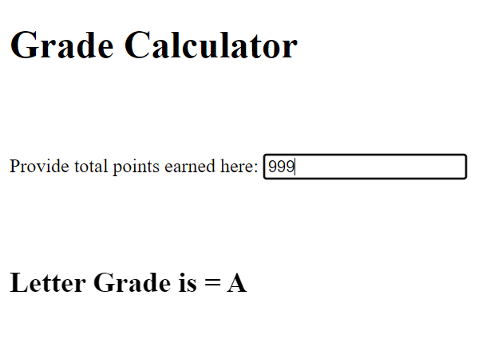

Point value entry 2:

Point value entry 3:

BONUS – warning user that negative values are invalid:

BONUS – warning user that values over 1000 are invalid:

